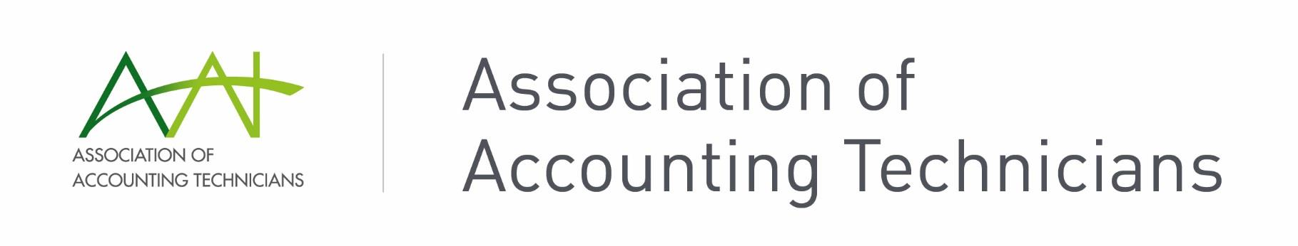

**STP FAQs**

**Q. When does each pay event need to be reported by?**

**A.** The ATO stipulates pay events must be report on the day of, or before the date of payment.

If the registered agent has a lodgment concession for micro employer clients (1-4 employees) then pay events can be lodged quarterly instead of at each pay run.

**Q. What are the penalties for late lodgements?**

**A.** Late lodgment penalties are the same as failure to lodge activity statement penalties, that is, one penalty unit per 28 days, up to a maximum of five units. The penalty unit value from 1 July 2020 is $222.

**Q. Who can lodge STP pay events?**

**A.** Any authorised person in the business can lodge STP pay events once the software is set up and connected to the ATO, provided they have payroll admin access. BAS agents are able to lodge on behalf of the business as STP, however bookkeepers may not lodge STP on behalf of a business owner.

**Q. Do I need an authority form?**

**A.** Authority forms are required for BAS agents who will lodge STP pay events on behalf of clients. An authority is required for each lodgment.

BAS agents can use an annual authorisation for lodgments if they meet the criteria.

**Q. What happens if an employee doesn’t have a MyGov account?**

**A.** STP data is automatically uploaded to the employee myGov account. The employee can request a payment summary from the employer if they do not wish to access the information via their myGov account.

**Q. Do I need to lodge EMPDUPE files?**

**A.** In STP the final declaration made through payroll software replaces the need to upload an EMPDUPE file to the BAS portal for most employee payments.

However, if you have other payments that require withholding and are not reported through STP (for example, no ABN or royalty payments), you will need to prepare payment summaries separately and lodge EMPDUPE files via ATO online services.

page1image3900544



**Q. Does STP change payment schedules for PAYG or superannuation?**

**A.** No. STP reports tax and super information to the ATO, but it does not change payment schedules for liabilities.

**Q. When is the final declaration for STP due each year?**

**A.** STP final declaration is due by 14 July each year for businesses with 20 or more employees.

For businesses with 19 or fewer employees, finalisation is due by 31 July.

**Q. Can manual payment summaries still be used?**

**A.** Yes, payment summaries can still be issued manually whilst reporting through STP, although employees are encouraged to move to using myGov accounts for all employer related information.

**Q. Can payment summaries still be printed from software?**

**A.** Yes, each software has a different process for accessing the payment summaries, but generally you can choose to run payment summary reports separate to STP reporting. Some employees may still request a payment summary, even though they have the information available in their myGov account.

**Q. How do we account for directors’ adjustments/end of period additions?**

**A.** Anything needing to be included in the year’s payroll should be entered via a pay run, whether it’s a standard or adjusting pay run entry. These end of year payments should be included in STP reporting.